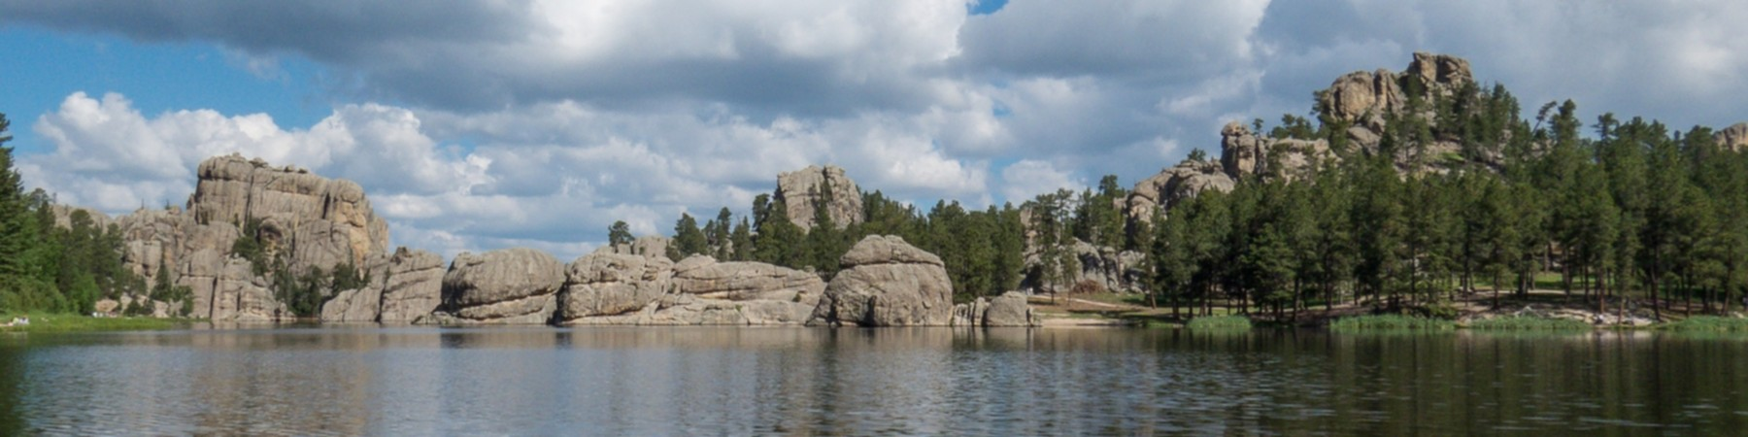


South Dakota Retired School Personnel



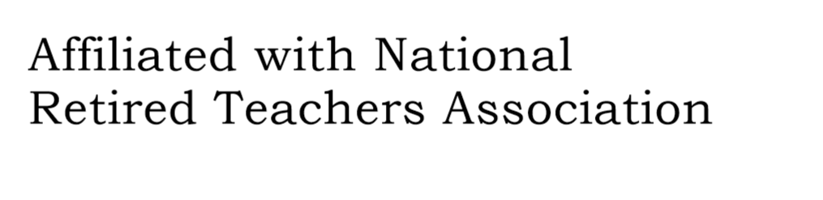
www.SDRSP.org Special Edition, March 2023
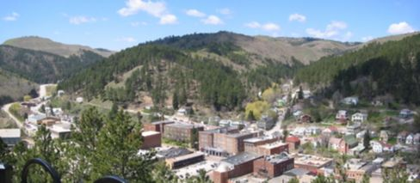

Convention Information
Year Book
Bill Zubke has offered to make an SDRSP Yearbook. Each convention registrant is invited to send:
- A current picture and one from 1966 (or thereabout) either digitally or a copy by mail.
- Tell where you lived in the 60’s photo and also where you are living in the current photo.
- Share the name of your favorite song/group from the 60’s, if you had one.
- Include where you have taught and the year you graduated (actually, year you retired).
- Finally, a hint or word of advice to those still teaching that was successful or helpful during your career.
Include “SDRSP Yearbook” on the subject line of the email. Bill’s info is bzubke@hotmail.com or Bill Zubke, 417 N Broadway, Watertown SD 57201
To give Bill time to compile, please have the pictures and info to him by April 10, 2023.

Pre-Convention Tour – Tatanka, Story of the Bison. On Tuesday, May 2, be at The Lodge entrance at 8:45 a.m. for loading the bus.

Door Prizes – Each Unit is invited to bring a gift basket for a door prize.

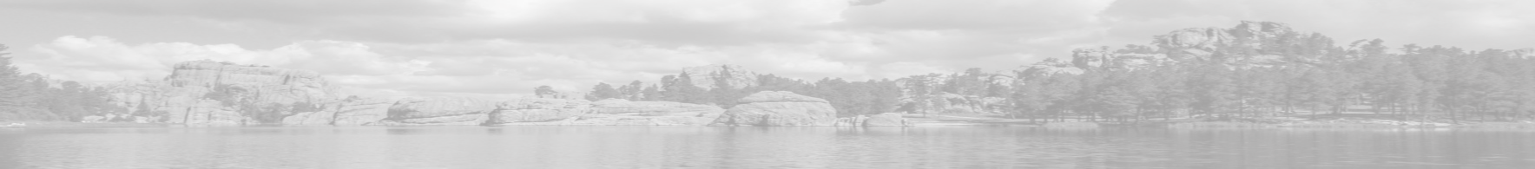
Books on Country Schools – Betsey DeLoache has 3 volumes of Country Schools: Past and Present, plus notecards, limited edition prints and a coloring book. Prices and lists of illustrations were sent via Unit Presidents.

Make checks to Red Bird Studio, 8842 Shell House Road, Edisto Island, SC 29438, Credit cards call 605-222-0665. Order by April 21 so that she can bring them to the convention, instead of you paying additional postage.

Book Exchange – Each convention attendee is invited to bring a used book or two or three to exchange. If you bring two, you can take two, etc.

Nominations for Florence Krieger and Outstanding Service Awards
Each year SDRSP accepts nominations for two awards to be given at the convention.

The first one is called the Florence Krieger award. It is given to someone who has served both SDRSP as an officer or in committee work and has also been active as an officer or committee member on the local unit level. Find the nomination form at https://www.sdrsp.org under the “More” dropdown and listed under Awards.

The second one is the Outstanding Service Award. Each unit may submit this nomination of a person in their unit who has given outstanding service to the unit and community. The form is also under the “More” dropdown and listed under Awards at https://www.sdrsp.org.

Both award nominations are to be sent to Jacque Sly, SDRSP President, by April 5, 2023.

Scholarship Application
In 2011 SDRSP began offering one $1000 scholarship, available to any South Dakota K-12 teacher with at least 5 years of experience who is working on an advanced degree or national board certification. The idea was so popular and economically supported by our members that we now offer two $1000 scholarships a year.

The scholarship application form is on the SDRSP website (https://www.sdrsp.org). Send the application digitally to Cathy Anderson (cander451@msn.com) by April 10, 2023.



This special e-edition of the SDRSP newsletter is devoted to the upcoming convention being held at The Lodge in Deadwood SD on May 2 & 3.

A committee of 3, including Rhonda Preller, Carm Tobin and Pat Johnson have been working to update and revise the Bylaws and Standing Rules of SDRSP. The proposed changes are included in this newsletter. The current Bylaws are available on the website: www.sdrsp.org. It is helpful to compare the original document with the proposed changes. The revisions and changes to the Bylaws and Standing Rules will be voted on at the convention. The last time there were major amendments was in 2015, with a small change in 2019.
There is a time for everything. Well, there is a twist of that quote that makes it worthwhile to get some things taken care of in the next few weeks:
It is time for applications and nominations for scholarships and awards to be submitted.
It is time for pictures to be sent for the year book.
It is time for reservations at the hotel.
It is time for registering for the convention.
It is time for submitting community service hours.
It is time for sending information of members who have passed this year.
It is time for ordering books from Betsey DeLoache, if you are interested.

Elsewhere in the newsletter is a timeline that gives dates and contact info for accomplishing the tasks at hand.

See you in Deadwood!

IMPORTANT
*The proposed revisions to the Bylaws are being sent as a separate document.

You will need to read the current Bylaws while comparing it to the revisions. These
Bylaws are found on the SDRSP website. Here is the link:
https://www.sdrsp.org/uploads/8/0/0/8/80088600/bylaws_pdf.pdf

*Please Note the registration form for convention is attached separately.


Deadline | Activity and Point of Contact
In Progress | Grandparent's Essay
 | Donna Fisher ddfisch@vyn.midco.net
5-Apr | Florence Krieger Award nomination
5-Apr | Outstanding Service Award nomination
 | Jacque Sly jacsly48@gmail.com
10-Apr | Year Book pics and info - Convention
 | Bill Zubke bzubke@hotmail.com
10-Apr | Community Service Volunteer Hours
 | Diane Odland odlandjoel@yahoo.com
10-Apr | Scholarship application
 | Cathy Anderson cander451@msn.com
25-Apr | Deadline for rooms - Convention - call The Lodge
25-Apr | Deadline for registration - Convention
 | Registration also on-line www.sdrsp.org
 | Merry Bleeker 1435 City Springs Rd Rapid City SD 57702
15-Apr | Notice of member's death
 | Actually goes until Apr 30, but need time to plan service
 | Mary Wilson Mary.Wilson@mit.midco.net
May 2-3 | Convention Deadwood
 | Pre-tour at 9:00 May 2, First session @ 1:00 p.m.
 | May 3, ends after lunch
 | Note that checks will not be cashed until around time of convention
 | NOTE THAT FORMS AND APPLICATIONS ARE ON THE
 | SDRSP WEBSITE. www.sdrsp.org
If you need | help, contact Jacque Sly jacsly48@gmail.com
 | 605-343-4956 home 605-381-9116 cell for texting

SDRSP Convention May 2-3, 2023 The Lodge, Deadwood SD
Where Were You in 1966?
Monday 5/1 7:30 p.m. Annual Board Meeting – SDRSP State Officers
Tuesday 5/2 8:00 a.m. Registration opens
8:45 Board bus for pre-convention tour - Tatanka Story of the Bison
The Convention Begins
Tuesday 5/2 1:00 First General Session
Welcome
Roll Call: Where were you in 1966?

1:45 Betsey DeLoache – Country Schools
2:45 Break
3:00 Well Done Players
3:30 AMBA
Second General Session 1960’s attire encouraged
6:00 Social hour
6:30 Dinner
Awards
Special Presentation: History of SDRSP

Wed 5/3 7:30 – 8:30 Breakfast available
7:30- 8:15 Unit Reps/Leadership Meeting with SDRSP Board
Third General Session
8:30 Memorial Service
8:45 Business Meeting

Fourth General Session
9:30 NRTA/AARP - Al Campos/Erik Gaikowski
10:00 Break
10:15 Diane Spilde – Preserving Memories
10:45 Bill and Cathy Zubke – Brain Health
11:30 Lunch - Grandparent’s Essay, Awards

